**Object Description**

**Overview**

|  |  |
| --- | --- |
| **Object Type** | **Object Name** |
| Sequences | style_id_seq  elevation_id_seq |
| Views | option_view  construction_stage |
| Procedures | ongoing_task  house_price_query (house_id) |
| Function | avg_price_by_style (style_name) |
| Package | Procedure: fire_employee (employee_id)  Procedure:hire_employee (employee_id) |
| Triggers | contract_completion_date  constructionsheet_stage |
| Scheduled Job | task_schedule |
| Roles | sales_representative  construction_mgr  buyers |
| De-normalization | Materialized view: construction_progress |
| Alternate Indexes | subdivision_idx  room_idx |

**2 Sequences**

* **style_id_seq**: a sequence of consecutive numbers starting from 1 and increasing by 1; can serve as surrogate key for table style (the primary key is style_name).

ALTER TABLE style ADD style_id NUMBER(4,0);

DROP SEQUENCE style_id_seq;

CREATE SEQUENCE style_id_seq

INCREMENT BY 1;

UPDATE style

SET style_id = style_id_seq.NEXTVAL;

COMMIT;

SELECT *

FROM style;

Before sequence was added After sequence was added

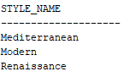 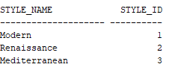

* **elevation_id_seq**: a sequence of consecutive numbers starting from 1 and increasing by 1; can serve as surrogate key for table elevation (the primary key is elevation_name).

ALTER TABLE elevation ADD elevation_id NUMBER(4,0);

DROP SEQUENCE elevation_id_seq;

CREATE SEQUENCE elevation_id_seq

INCREMENT BY 1;

UPDATE elevation

SET elevation_id = elevation_id_seq.NEXTVAL;

COMMIT;

SELECT *

FROM elevation;

Before sequence was added



After sequence was added



**2 Views**

* **option_view:** A view based on table “Option” that restricts users(house buyers) from seeing the cost and revision date of options.

CREATE OR REPLACE VIEW option_view AS

SELECT option_id, option_no, option_desc, stage, category, style_name FROM "Option";

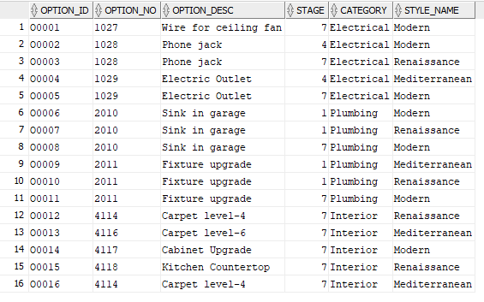

* **construction_stage:** A view based on table constructionsheet that only shows users the constructions on stage 1, 4, or 7.

CREATE OR REPLACE VIEW construction_view AS

SELECT * FROM constructionsheet

WHERE stage = 1 OR stage = 4 OR stage = 7;

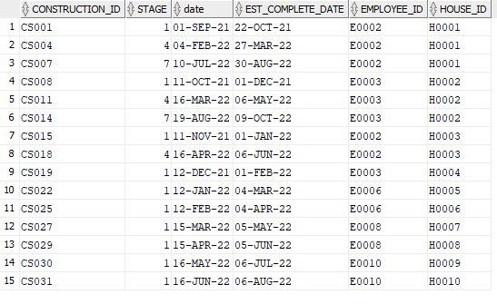

These view create a restricted subset of data to show users part of the dataset. It will not affect the performance of the original tables.

**2 Procedures**

* **ongoing_task:** a procedure that shows all construction managers who have ongoing constructions (percentage completed less than 100), their ongoing task, and the percentage completed.

CREATE OR REPLACE

PROCEDURE ongoing_task

AS TYPE ongoing_type IS RECORD

(

construction_id1 constructionsheet.construction_id%TYPE,

employee_id1 constructionsheet.employee_id%TYPE,

fullname employee.fname%TYPE,

house_id1 constructionsheet.house_id%TYPE,

task_id1 taskprogress.task_id%TYPE,

percent_complete1 taskprogress.percent_complete%TYPE,

task_desc1 task.task_desc%TYPE);

ongoing_task_record ongoing_type;

CURSOR task_cursor IS

SELECT c.construction_id, c.employee_id, CONCAT(CONCAT(e.fname,' '),

e.lname) AS fullname, c.house_id, tp.task_id, tp.percent_complete, t.task_desc

FROM constructionsheet c, taskprogress tp, task t, employee e

WHERE c.construction_id = tp.construction_id

AND tp.task_id = t.task_id

AND c.employee_id = e.employee_id

AND tp.percent_complete < 100;

BEGIN

OPEN task_cursor;

LOOP

FETCH task_cursor INTO ongoing_task_record;

EXIT WHEN task_cursor%NOTFOUND;

DBMS_OUTPUT.PUT_LINE('+ +');

DBMS_OUTPUT.PUT_LINE('Employee ID: '||ongoing_task_record.employee_id1);

DBMS_OUTPUT.PUT_LINE('Employee Name: '||ongoing_task_record.fullname);

DBMS_OUTPUT.PUT_LINE('Construction ID: '||ongoing_task_record.construction_id1);

DBMS_OUTPUT.PUT_LINE('House ID: '||ongoing_task_record.house_id1);

DBMS_OUTPUT.PUT_LINE('Task ID: '||ongoing_task_record.task_id1);

DBMS_OUTPUT.PUT_LINE('Task Description: '||ongoing_task_record.task_desc1);

DBMS_OUTPUT.PUT_LINE('Percent Complete: '||ongoing_task_record.percent_complete1);

END LOOP;

CLOSE task_cursor;

END;

/

Sample Output:

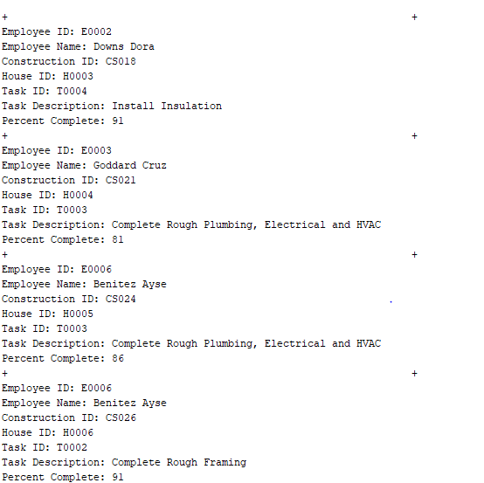

* **house_price_query:** Sa procedure that shows house base price, elevation price, each decorator choice price and the total price of the chosen house. It takes input parameter = house_id

CREATE OR REPLACE

PROCEDURE house_price_query(houseid1 IN house.house_id%TYPE)

AS

house_id house.house_id%TYPE;

house_price house.base_price%TYPE;

elevation_price elevation.Additional_cost_sketch%TYPE;

decoration_count NUMBER(2) :=1; -- use to number decoration 1, 2, ...

total_cost NUMBER(15); -- sum the total price

is_empty boolean := true; -- to check is the cursor (decoration record is empty)

-- Use cursor because a house could have several kinds of decoration

-- Note: a house can only have 1 base price and elevation price

CURSOR c1(houseid2 house.house_id%TYPE)

IS

SELECT o.option_desc, d.item_price

FROM house h, "Option" o, decoratorchoice d

WHERE h.house_id(+) = d.house_id

AND d.option_id = o.option_id

AND h.house_id = houseid2;

BEGIN

-- if a price is null, change it to 0

SELECT h.house_id, COALESCE(h.base_price,0), COALESCE(e.Additional_cost_sketch,0)

INTO house_id, house_price, elevation_price

FROM house h, lot l, elevation e

WHERE e.elevation_name = l.elevation_name

AND l.house_id = h.house_id

AND h.house_id = houseid1

GROUP BY h.house_id, h.base_price, e.Additional_cost_sketch;

DBMS_OUTPUT.PUT_LINE('House ID: '||house_id);

DBMS_OUTPUT.PUT_LINE('House Base Price: $'||house_price);

DBMS_OUTPUT.PUT_LINE('Elevation Price: $'||elevation_price);

total_cost := house_price + elevation_price; -- do the sum

-- get all the decorations and print them out

FOR item in c1(houseid1)

LOOP

DBMS_OUTPUT.PUT_LINE('Decoration '||decoration_count||': '||item.option_desc);

DBMS_OUTPUT.PUT_LINE(' Price: $'||item.item_price);

total_cost := total_cost + item.item_price; -- do the sum

decoration_count := decoration_count+1; -- add the decoration number

is_empty := false; -- if the cursor is not empty, change to false

END LOOP;

IF is_empty THEN

DBMS_OUTPUT.PUT_LINE('No decoration yet');

END IF;

DBMS_OUTPUT.PUT_LINE('Total: $'|| total_cost);

EXCEPTION

WHEN no_data_found THEN

DBMS_OUTPUT.PUT_LINE('NO such house');

ROLLBACK;

END;

-- execute house_price_query('H0001');

-- execute house_price_query('H0003');

-- execute house_price_query('H0007');

-- execute house_price_query('H0000');

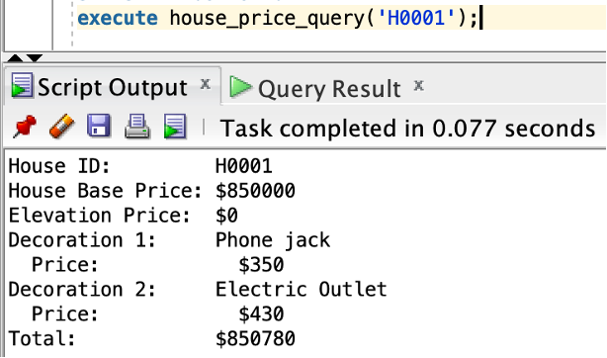

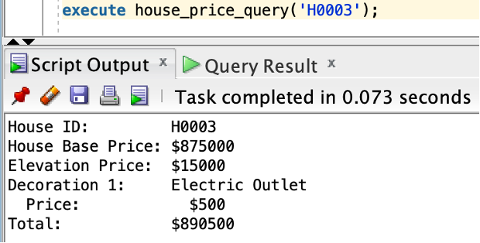

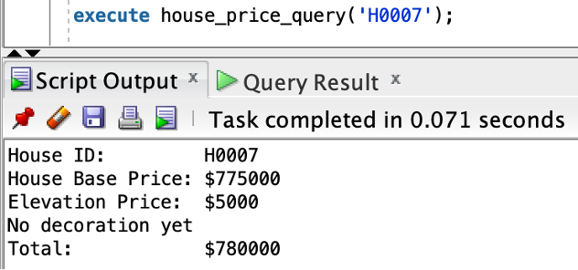

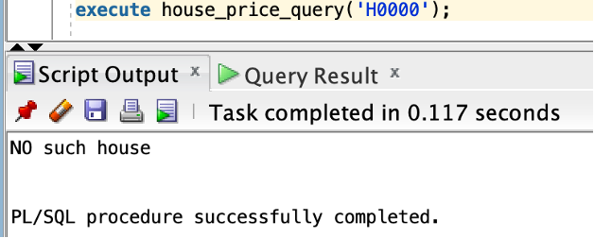

**1 Function**

* **avg_price_by_style**: a function that takes in style name as one parameter, calculates the average base price of all houses on file of the given style, and returns the price.

CREATE OR REPLACE FUNCTION avg_price_by_style (style_n VARCHAR)

RETURN NUMBER

IS

avg_price NUMBER;

BEGIN

SELECT AVG(base_price)

INTO avg_price

FROM style JOIN lot USING(style_name)

JOIN house h USING(house_id)

GROUP BY style_name

HAVING style_name = style_n;

RETURN avg_price;

END avg_price_by_style;

Sample Output:

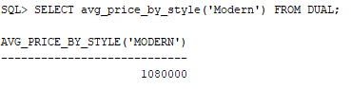

**1 Package**:

* **Hiring and Firing employees**

By inserting a new employee’s Imployee_id, firstname, lastname, position, licences, we can successfully add those information to employee table in our database.

By inserting employee’ ID, the company can fire that person and delete related information in the database if the employee no longer serving any jobs.

CREATE OR REPLACE PACKAGE c_package AS

PROCEDURE fire_employee(employeeid IN employee.employee_id%TYPE);

PROCEDURE hire_employee(employeeid IN employee.employee_id%TYPE,

lastname IN employee.lname%TYPE,

firstname IN employee.fname%TYPE,

title IN employee.title%TYPE,

license IN employee.license_no%TYPE);

END c_package;

/

CREATE OR REPLACE PACKAGE BODY c_package AS

-- first procedure starts

PROCEDURE hire_employee(employeeid IN employee.employee_id%TYPE,

lastname IN employee.lname%TYPE,

firstname IN employee.fname%TYPE,

title IN employee.title%type,

license IN employee.license_no%TYPE)

IS

BEGIN

INSERT INTO employee

VALUES(employeeid, lastname, firstname, title, license);

DBMS_OUTPUT.PUT_LINE('Employee hired: '||employeeid||' '||firstname||' '||lastname);

END hire_employee;

-- first procedure ends

-- second procedure starts

PROCEDURE fire_employee(employeeid IN employee.employee_id%TYPE)

IS

constructor_manager_ornot NUMBER;

sells_manager_ornot NUMBER;

decorator_choice_ornot NUMBER;

no_number EXCEPTION;

BEGIN

SELECT count(*) INTO decorator_choice_ornot

FROM employee e, decoratorchoice d

WHERE e.employee_id = d.employee_id

AND e.employee_id = employeeid;

SELECT count(*) INTO constructor_manager_ornot

FROM employee e, constructionsheet c

WHERE e.employee_id = c.employee_id

AND e.employee_id = employeeid;

SELECT count(*) INTO sells_manager_ornot

FROM employee e, contract c

WHERE e.employee_id = c.employee_id

AND e.employee_id = employeeid;

IF constructor_manager_ornot != 0 THEN

DBMS_OUTPUT.PUT_LINE('You can not fire a construction manager!');

ELSIF sells_manager_ornot != 0 THEN

DBMS_OUTPUT.PUT_LINE('You can not fire a sales manager!');

ELSIF decorator_choice_ornot != 0 THEN

DBMS_OUTPUT.PUT_LINE('You can not fire a decorator choice manager!');

ELSE

DBMS_OUTPUT.PUT_LINE('FIRE '||employeeid);

DELETE FROM employee

WHERE employee.employee_id = employeeid;

IF SQL%NOTFOUND THEN

RAISE no_number;

END IF;

END IF;

EXCEPTION

WHEN no_number THEN

DBMS_OUTPUT.PUT_LINE('NO such employee');

ROLLBACK;

END fire_employee;

--second procedure ends

END c_package;

/

Sample output:

* Adding a new employee named Garth Brooks with a title of assitant.
* Deleting employee E0010 and results are the same in that this employee is still in charge of some jobs and can not be fired.

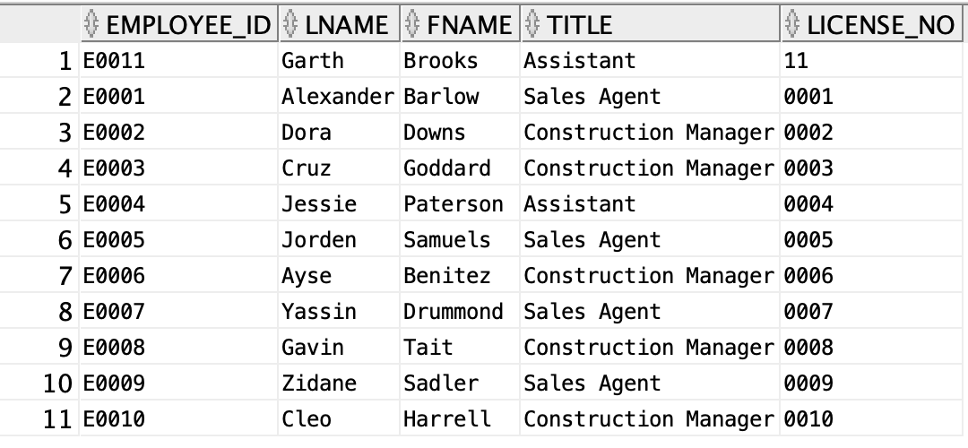

**2 Triggers**

* **contract_completion_date**: This trigger will check if the new records inserted to and records updated in the table “contract” are valid before insertion and update. Valid records will have est_complete_date within 1 year after signed_date. If the record is valid, it will be successfully inserted or updated. A message will be printed out to inform users about the success of insert/update. And, for insertion, only new est_complete_date will be printed out. For update, both new record’s and old record’s est_complete_date and signed_date will be printed out. If the record is not valid (i.e., est_complete_date is beyond 1 year of signed_date), an exception will be raised and the error message will be printed out.

REM Trigger1: check contract's estimate completion date

CREATE OR REPLACE TRIGGER

contract_completion_date

BEFORE INSERT OR UPDATE ON contract /* contract table*/

FOR EACH ROW

DECLARE

unacceptable_est_completion EXCEPTION;

BEGIN

IF (TO_DATE(:new.est_complete_date) < add_months(TO_DATE(:new.signed_date), 12))

THEN

DBMS_OUTPUT.PUT_LINE('Contract Added/Updated');

DBMS_OUTPUT.PUT_LINE('New Estimated Complete Date: ' || :new.est_complete_date);

DBMS_OUTPUT.PUT_LINE('New Signed Date: ' || :new.signed_date);

DBMS_OUTPUT.PUT_LINE('Old Estimated Complete Date: ' || :old.est_complete_date);

DBMS_OUTPUT.PUT_LINE('Old Signed Date: ' || :old.signed_date);

ELSE

RAISE unacceptable_est_completion;

END IF;

EXCEPTION

WHEN unacceptable_est_completion THEN RAISE_APPLICATION_ERROR (-20326,'There is an error in input estimated completion date. It must be within 1 year of signed date. ');

END contract_completion_date;

/

ALTER TRIGGER contract_completion_date ENABLE;

REM Insert a house with no contract to test on the trigger

INSERT INTO house

VALUES ('H0011', 549500.00, NULL,500.00, NULL,1);

1 row inserted.

REM insert into contract with est_completion_date within required date

INSERT INTO contract

VALUES

('C0011', 'H0011', 'B0001', 'E0001', 'Portfolio Loan', 850000.00, 'EA001', 'BA003', '9-Sep-2022', '10-Sep-2021', 1, 1, 1);

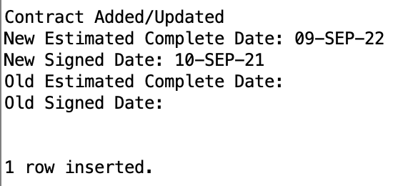

REM delete from contract if the record to be inserted already exist

DELETE FROM contract

WHERE contract_id = 'C0011';

1 row deleted.

REM insert into contract with est_completion_date outside required date

INSERT INTO contract

VALUES

('C0011', 'H0011', 'B0001', 'E0001', 'Portfolio Loan', 850000.00, 'EA001', 'BA003', '20-Sep-2022', '10-Sep-2021', 1, 1, 1);

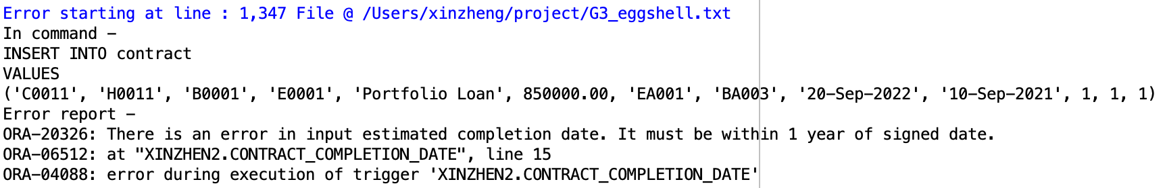

delete from house

WHERE house_id = 'H0011';

1 row deleted.

* **Constructionsheet_stage**: This trigger will check if the new record inserted to and the record updated in the table “constructionsheet” have a valid stage before insertion and update. The stage updated or inserted will need to be greater than the nearest stage by 1 according to the corresponding house number. For example, if the most recent stage of any task is 2, the newly inserted/updated stage must be 3. If the record is valid, a message informing the user about the success will be printed out. And, for insertion, the new stage will be printed out. For update, both the new stage and old stage will be printed out. If the record is invalid, an exception will be raised.

REM Trigger2

CREATE OR REPLACE TRIGGER

constructionsheet_stage

BEFORE INSERT OR UPDATE ON constructionsheet

FOR EACH ROW

DECLARE

v_max_stage constructionsheet.stage%TYPE;

unacceptable_stage EXCEPTION;

BEGIN

SELECT MAX(stage) INTO v_max_stage

FROM constructionsheet

WHERE :new.house_id = constructionsheet.house_id;

IF :new.stage = v_max_stage + 1 THEN

DBMS_OUTPUT.PUT_LINE('ConstructionSheet Added/Updated');

DBMS_OUTPUT.PUT_LINE('New Stage: ' || :new.stage);

DBMS_OUTPUT.PUT_LINE('Old Stage: ' || :old.stage);

ELSE

RAISE unacceptable_stage;

END IF;

EXCEPTION

WHEN unacceptable_stage THEN RAISE_APPLICATION_ERROR (-20326,'There is an error in the input stage. Stage must be greater than the current stage by 1.');

END constructionsheet_stage;

/

INSERT INTO constructionsheet

VALUES

('CS032', 2, '16-Jun-2022', '06-Aug-2022', 'E0010', 'H0010');

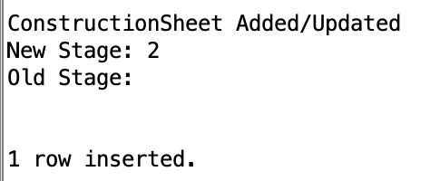

INSERT INTO constructionsheet

VALUES

('CS033', 2, '16-Jun-2022', '06-Aug-2022', 'E0010', 'H0010');

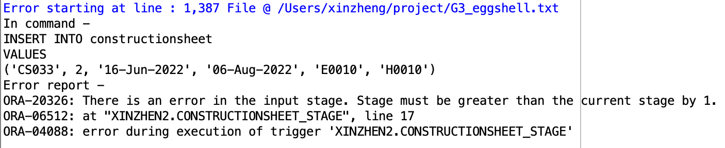

DELETE FROM constructionsheet where construction_id = 'CS032';

**1 Scheduled Job**

* **task_schedule:** A schedule job to update the column percent_complete in tabletaskprogress. It is used to update the task progress on a daily basis. The scheduled job adds 1 to all percentage completed that are less than 100 every day starts from the job created date.

BEGIN

DBMS_SCHEDULER.CREATE_JOB (

job_name => 'task_schedule',

job_type => 'PLSQL_BLOCK',

job_action => 'UPDATE taskprogress

SET percent_complete = percent_complete+1

WHERE percent_complete <100;',

start_date => sysdate,

repeat_interval => 'FREQ=DAILY',

enabled => true);

END;



**3 Roles**

* **sales_representative:** The role of sales representative will be able to see all the tables except for the table “employee”. This role will be able to select, insert, update and delete the tables “decoratorchoice”, “contract”, “house”, and “buyer”. A sales representative needs to create, modify or delete contracts and houses. The sales representative also needs to create, modify, or delete a buyer and create, modify or delete decorator choice sheets. This role will be able to select from “subdivision”, “"Subdivision-Style", “style”, “Option”, “Style-Elevation”, “schooldistrict”, “school”, “house”, “lot”, “elevation”, “room”, “constructionsheet”, “task”, “agent”, “bank”, and “employee”.   
    
  As the role **sales_representative** has been created, during the actual test, it is possible that an error will be raised since the role has been created. Please change the name of the role if you would like to correctly create the role and grant it to a new user. In our run, the role is successfully created and the result is attached below along with the granting process to the new user and how to test it from the new user’s account.

REM create a role of sales representative

CREATE ROLE sales_representative;

GRANT select, insert, update, delete ON decoratorchoice TO sales_representative;

GRANT select, insert, update, delete ON contract TO sales_representative;

GRANT select, insert, update, delete ON buyer TO sales_representative;

GRANT SELECT, insert, update, delete ON house TO sales_representative;

GRANT SELECT ON subdivision TO sales_representative;

GRANT SELECT ON "Subdivision-Style" TO sales_representative;

GRANT SELECT ON style TO sales_representative;

GRANT SELECT ON "Option" TO sales_representative;

GRANT SELECT ON "Style-Elevation" TO sales_representative;

GRANT SELECT ON schooldistrict TO sales_representative;

GRANT SELECT ON school TO sales_representative;

GRANT SELECT ON lot TO sales_representative;

GRANT SELECT ON elevation TO sales_representative;

GRANT SELECT ON room TO sales_representative;

GRANT SELECT ON constructionsheet TO sales_representative;

GRANT SELECT ON task TO sales_representative;

GRANT SELECT ON agent TO sales_representative;

GRANT SELECT ON bank TO sales_representative;

GRANT SELECT ON employee TO sales_representative;

To test the role, we grant the role “sales_representative” to the user advdb. To ensure the role has been successfully granted, open a new window and switch to the user advdb. Try to update the table “sudivision” on the other user’s schema. An error will be raised indicating that the user advdb does not have privilege to do so. Then, test to insert a new record into the table “house” on the other user’s scheme. The row will be successfully inserted.

GRANT sales_representative TO advdb;

REM update with NO priviledge

update SCHEMA_USERNAME.subdivision

set map = 'no map'

where subdivision_id = 'S0001';

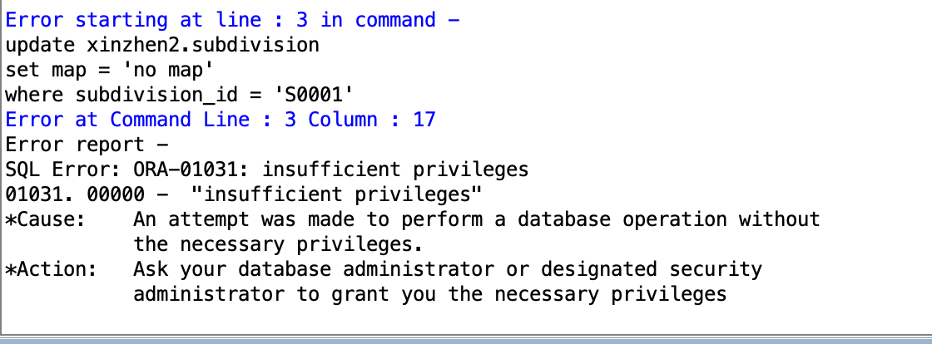

REM Insertion with privilege

INSERT INTO SCHEMA_USERNAME.house

VALUES

('H0011', 789000, NULL, 800, NULL, 1);

1 row inserted.

DELETE FROM SCHEMA_USERNAME.house

WHERE house_id = 'H0011';

1 row deleted.

* **Construction_Mgr:** The role of construction will be able to see all the tables except for the table “employee”. This role will be able to select, insert, update and delete the tables “constructionsheet”, “task”, “room”, and “house”, “elevation”, “subdivision”, “Subdivision-Style”, “style”, “Option”, and “Style-Elevation”. A construction manager needs to create, modify or delete houses. The construction manager also needs to create, modify, or delete any construction related table with the house. This role will be able to select from “lot”, “schooldistrict”, “school”, “agent”, “bank”, “decoratorchoice”, and “contract”.

As the role **Construction_Mgr** has been created, during the actual test, it is possible that an error will be raised since the role has been created. Please change the name of the role if you would like to correctly create the role and grant it to a new user. In our run, the role is successfully created and the result is attached below along with the granting process to the new user and how to test it from the new user’s account.

REM create role of construction manager

CREATE ROLE construction_mgr;

GRANT select, insert, update, delete ON constructionsheet TO construction_mgr;

GRANT select, insert, update, delete ON task TO construction_mgr;

GRANT select, insert, update, delete ON room TO construction_mgr;

GRANT select, insert, update, delete ON house TO construction_mgr;

GRANT select, insert, update, delete ON elevation TO construction_mgr;

GRANT select, insert, update, delete ON subdivision TO construction_mgr;

GRANT select, insert, update, delete ON "Subdivision-Style" TO construction_mgr;

GRANT select, insert, update, delete ON style TO construction_mgr;

GRANT select, insert, update, delete ON "Option" TO construction_mgr;

GRANT select, insert, update, delete ON "Style-Elevation" TO construction_mgr;

GRANT select ON lot TO construction_mgr;

GRANT select ON schooldistrict TO construction_mgr;

GRANT select ON school TO construction_mgr;

GRANT select ON agent TO construction_mgr;

GRANT select ON bank TO construction_mgr;

GRANT select ON decoratorchoice TO construction_mgr;

GRANT select ON contract TO construction_mgr;

GRANT select ON buyer TO construction_mgr;

To test the role, we grant the role “construction_mgr” to the user advdb. To ensure the role has been successfully granted, open a new window and switch to the user advdb. Try to update the table “contract” on the other user’s schema. An error will be raised indicating that the user advdb does not have privilege to do so. Then, test to insert a new record into the table “style” on the other user’s scheme. The row will be successfully inserted.

GRANT construction_mgr TO advdb;

INSERT INTO SCHEMA_USERNAME.contract

VALUES

('C0011', 'H0011', 'B0001', 'E0001', 'Portfolio Loan', 850000.00, 'EA001', 'BA003', '9-Sep-2022', '10-Sep-2021', 1, 1, 1);

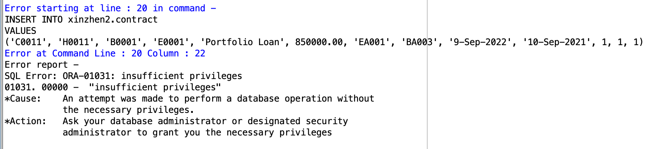

INSERT INTO SCHEMA_USERNAME.style

VALUES

('new style', 4);

1 row inserted.

* **Buyers:** The role of buyers will be able to see the tables related to house. They will only be able to see construction stage 1, 4, and 7. Two views are created for users to see the construction progress. The buyers will be able to see tables “subdivision”, “Subdivision-Style”, “ style”, “Style-Elevation”, “schooldistrict”, “school”, “house”, “lot”, “elevation”, and “room”. The buyers will be able to see two views: “construction_stage” and “option_view”.

As the role **Buyers** has been created, during the actual test, it is possible that an error will be raised since the role has been created. Please change the name of the role if you would like to correctly create the role and grant it to a new user. In our run, the role is successfully created and the result is attached below along with the granting process to the new user and how to test it from the new user’s account.

REM create role of buyer

CREATE ROLE buyers;

GRANT SELECT ON subdivision TO buyers;

GRANT SELECT ON "Subdivision-Style" TO buyers;

GRANT SELECT ON style TO buyers;

GRANT SELECT ON "Style-Elevation" TO buyers;

GRANT SELECT ON schooldistrict TO buyers;

GRANT SELECT ON school TO buyers;

GRANT SELECT ON house TO buyers;

GRANT SELECT ON lot TO buyers;

GRANT SELECT ON elevation TO buyers;

GRANT SELECT ON room TO buyers;

GRANT select ON construction_stage to buyers;

GRANT SELECT ON option_view to buyers;

To test the role, we grant the role “buyers” to the user advdb. To ensure the role has been successfully granted, open a new window and switch to the user advdb. Try to update the table “contract” on the other user’s schema. An error will be raised indicating that the user advdb does not have privilege to do so. Then, test to select a new record to see the view “construction_stage” on the other user’s scheme.

GRANT buyers TO advdb;

INSERT INTO SCHEMA_USERNAME.contract

VALUES

('C0011', 'H0011', 'B0001', 'E0001', 'Portfolio Loan', 850000.00, 'EA001', 'BA003', '9-Sep-2022', '10-Sep-2021', 1, 1, 1);

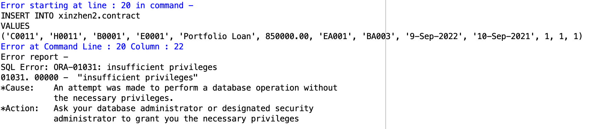

SELECT * FROM xinzhen2.construction_stage;

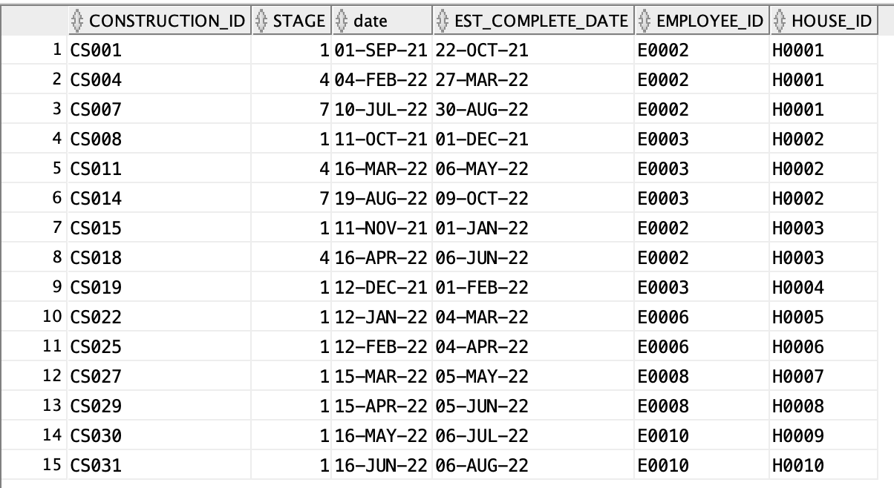

**1 De-normalization**

* We denormalized the originally normalized entities ConstructionSheet, TaskProgress and Task by creating a materialized view construction_progress. This view joined three tables to aggregate all tasks and task progress for constructions, which can lead to repeated/redundant information for construction_id and task_id but can also improve the read performance of our database, although at the expense of losing some write performance.
* In this case, when database users want to know the the tasks progress of one specific house, either in one specific stage or all stages, they don’t have to join all three tables mentioned above but directly retrieve the information from the materialized view construction_progress, increasing query efficiency. This view will be updated whenever there’s an update in any of the three tables.

CREATE MATERIALIZED VIEW construction_progress

REFRESH ON COMMIT

AS

SELECT c.house_id, c.stage, t.task_desc,tp.percent_complete

FROM constructionsheet c, taskprogress tp, task t

WHERE c.construction_id = tp.construction_id

AND t.task_id = tp.task_id;

Before denormalization

SELECT c.house_id, c.stage, t.task_desc, tp.percent_complete

FROM constructionsheet c JOIN taskprogress tp

USING(construction_id)

JOIN task t USING(task_id)

WHERE c.house_id = 'H0003';

After denormalization

SELECT *

FROM construction_progress

WHERE house_id = 'H0003';

**2 Alternate Indexes**

* **subdivision_idx**: unique alternate index for attribute subdivision_name in table subdivision because subdivision_name is a candidate key

CREATE INDEX subdivision_idx ON subdivision (subdivision_name);

This alternate index can help users retrieve information about subdivisions much more quickly without scanning through the whole table if they only know the subdivision names but not subdivision id, which is the primary key, thus making the whole process more time-saving and efficient.

Sample Query:

SELECT subdivision_id,subdivision_name, map

FROM subdivision

WHERE subdivision_name = ‘Palm Springs’;

* **room_idx**: unique alternate index for attribute room_name in table room because room_name is a candidate key

CREATE INDEX room_idx ON room (room_name);

This alternate index can help users retrieve information about room much more quickly without scanning through the whole table if they only know the room names but not the specific room id, which is the primary key, thus making the whole process more time-saving and efficient..

Sample Query:

SELECT hr.house_id, r.room_name, hr.floor,

hr."size", hr.num_window

FROM room r JOIN "House-Room" hr USING(room_id)

WHERE r.room_name = 'Study';